**Sample Written examination # 3 – By Jack Graffeo**

**November 2023**

**Reading time: 15 mins**

**Writing time: 2 hours**

**QUESTION AND ANSWER BOOK**

**Structure of the exam**

|  |  |  |  |  |  |
| --- | --- | --- | --- | --- | --- |
|  | *Section* | *Number of questions* | *Number of questions to be answered* | *Number of marks* |  |
|  | A | 12 | 12 | 60 |  |
|  | B | 4 | 1 | 20 |  |
|  |  |  |  | Total 80 |  |

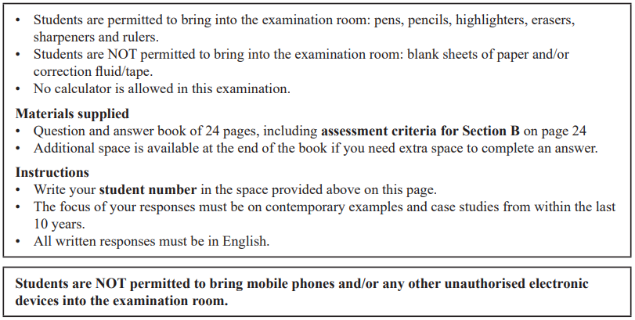

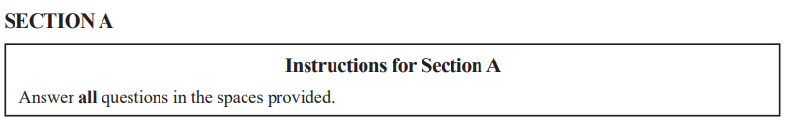

**Question 1** (2 marks)

Describe one example of a regional grouping in global politics.

|  |
| --- |
|  |
|  |
|  |
|  |
|  |
|  |

**Question 2** (3 marks)

Explain one role of the International Monetary Fund (IMF).

|  |
| --- |
|  |
|  |
|  |
|  |
|  |
|  |
|  |
|  |
|  |

**Question 3** (5 marks)

Evaluate the extent to which the International Criminal Court (ICC) has challenged state sovereignty.

|  |
| --- |
|  |
|  |
|  |
|  |
|  |
|  |
|  |
|  |
|  |
|  |
|  |
|  |
|  |
|  |
|  |

**Question 4** (6 marks)

Analyse the success of one terrorist non-state actor in achieving its aims.

|  |
| --- |
|  |
|  |
|  |
|  |
|  |
|  |
|  |
|  |
|  |
|  |
|  |
|  |
|  |
|  |
|  |
|  |
|  |
|  |

**Question 5 (14 marks)**

One of the following Asia-Pacific states must be used as the focus of all responses to Question 5: Australia, China, Indonesia, Japan or the United States of America.

Selected Asia-Pacific state: ____________________________________________________

1. Describe one factor shaping this Asia-Pacific state’s pursuit of economic prosperity. (3 marks)

|  |
| --- |
|  |
|  |
|  |
|  |
|  |
|  |
|  |
|  |
|  |

1. Explain how this Asia-Pacific state’s use of a foreign policy instrument has seen a marked difference between the intentions and results. (6 marks)

|  |
| --- |
|  |
|  |
|  |
|  |
|  |
|  |
|  |
|  |
|  |
|  |
|  |
|  |
|  |
|  |
|  |
|  |
|  |
|  |

1. Evaluate the effectiveness of this Asia-Pacific state’s use of political power to pursue international standing. (5 marks)

|  |
| --- |
|  |
|  |
|  |
|  |
|  |
|  |
|  |
|  |
|  |
|  |
|  |
|  |
|  |
|  |
|  |

**Question 6** (4 marks)

From the list below, select one ethical issue that you have studied this year:

**You must respond to the same ethical issue in Question 6 and 7.**

• human rights

• people movement

• development

• arms control

Ethical issue: _______________________________________________________________

Explain how cosmopolitanism has shaped one global actor’s response to this ethical issue.

|  |
| --- |
|  |
|  |
|  |
|  |
|  |
|  |
|  |
|  |
|  |
|  |
|  |
|  |

**Question 7** (6 marks)

Compare the extent to which two global actors responses to this ethical issue have upheld obligations under one international law.

**You must respond to the same ethical issue as Question 6.**

|  |
| --- |
|  |
|  |
|  |
|  |
|  |
|  |
|  |
|  |
|  |
|  |
|  |
|  |
|  |
|  |
|  |
|  |
|  |
|  |

**Question 8** (5 marks)

Select another ethical issue that you have studied this year. The ethical issue selected must be **different** from the one selected in Question 6 and 7.

Ethical issue ________________________________________________________________

Evaluate the effectiveness of one global actor’s pursuit of justice in relation to this ethical issue.

|  |
| --- |
|  |
|  |
|  |
|  |
|  |
|  |
|  |
|  |
|  |
|  |
|  |
|  |
|  |
|  |
|  |

**Question 9** (3 marks)

Using a specific example, explain the term ‘unilateralism’ as it relates to the study of global politics.

|  |
| --- |
|  |
|  |
|  |
|  |
|  |
|  |
|  |
|  |
|  |

**Question 10** (2 marks)

From the list below, select one global crisis that you have studied this year:

**You must respond to the same global crisis in Question 10 and 11.**

• climate change

• armed conflict

• terrorism

• economic instability

Global crisis: _______________________________________________________________

Outline one cause of this global crisis.

|  |
| --- |
|  |
|  |
|  |
|  |
|  |
|  |

**Question 11** (4 marks)

Explain one challenge to achieving the effective resolution of this global crisis.

**You must respond to the same global crisis as Question 10.**

|  |
| --- |
|  |
|  |
|  |
|  |
|  |
|  |
|  |
|  |
|  |
|  |
|  |
|  |

**Question 12** (6 marks)

From the table below, select a key aspect related to a global crisis that you have studied this year. The global crisis must be **different** as the one selected in Question 10 and 11.

|  |  |  |
| --- | --- | --- |
| **Global crisis** |  | **Key aspect** |
| Climate change | → | Resource exploitation |
| Armed conflict | → | Prosecuting war crimes in international law |
| Terrorism | → | Terrorism as an instrument of state policy |
| Economic instability | → | Capitalism’s boom-bust cycle |

Global crisis ________________________________________________________________

Analyse the key aspect related to this global crisis.

|  |
| --- |
|  |
|  |
|  |
|  |
|  |
|  |
|  |
|  |
|  |
|  |
|  |
|  |
|  |
|  |
|  |
|  |
|  |
|  |

**SECTION B**

Write an essay on one of the following questions in the space provided.

Your response will be assessed according to the assessment criteria set out on the back page.

**Question 1** (20 marks)

‘The ongoing need for states to pursue security and stability has brought about increased examination of the role of global governance.’ Analyse the extent to which intergovernmental organisations successfully facilitate global governance.

**OR**

**Question 2** (20 marks)

Don’t do this question, unless you want to do bad on this exam.

**OR**

**Question 3** (20 marks)

Evaluate the extent to which realism has shaped the responses of global actors to two ethical issues.

**OR**

**Question 4** (20 marks)

‘Unilateralism is both a response and an ongoing challenge to the effective resolution of global crises.’ Discuss with reference to two global crises.



|  |
| --- |
|  |
|  |
|  |
|  |
|  |
|  |
|  |
|  |
|  |
|  |
|  |
|  |
|  |
|  |
|  |
|  |
|  |
|  |
|  |
|  |
|  |
|  |
|  |
|  |
|  |
|  |
|  |
|  |
|  |
|  |
|  |
|  |
|  |
|  |
|  |
|  |
|  |
|  |
|  |
|  |
|  |
|  |
|  |
|  |
|  |
|  |
|  |
|  |
|  |
|  |
|  |
|  |
|  |
|  |
|  |
|  |
|  |
|  |
|  |
|  |
|  |
|  |
|  |
|  |
|  |
|  |
|  |
|  |
|  |
|  |
|  |
|  |
|  |
|  |
|  |
|  |
|  |
|  |
|  |
|  |
|  |
|  |
|  |
|  |
|  |
|  |
|  |
|  |
|  |
|  |
|  |
|  |
|  |
|  |
|  |
|  |
|  |
|  |
|  |
|  |
|  |
|  |
|  |
|  |
|  |
|  |
|  |
|  |
|  |
|  |
|  |
|  |
|  |
|  |
|  |
|  |
|  |
|  |
|  |
|  |
|  |
|  |
|  |
|  |
|  |
|  |
|  |
|  |
|  |
|  |
|  |
|  |
|  |
|  |
|  |
|  |
|  |
|  |
|  |
|  |
|  |
|  |
|  |
|  |
|  |
|  |
|  |
|  |
|  |
|  |
|  |
|  |
|  |
|  |
|  |
|  |
|  |
|  |
|  |
|  |

**END OF SECTION B**

**Extra space for responses.**

**Clearly number all responses in this space.**

|  |
| --- |
|  |
|  |
|  |
|  |
|  |
|  |
|  |
|  |
|  |
|  |
|  |
|  |
|  |
|  |
|  |
|  |
|  |
|  |
|  |
|  |
|  |
|  |
|  |
|  |
|  |
|  |
|  |
|  |
|  |
|  |
|  |
|  |
|  |
|  |
|  |
|  |
|  |
|  |
|  |
|  |
|  |
|  |
|  |
|  |
|  |
|  |
|  |
|  |
|  |
|  |

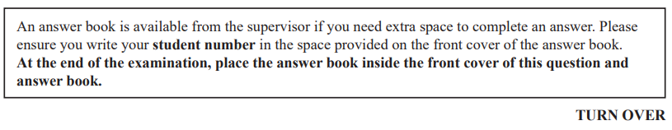

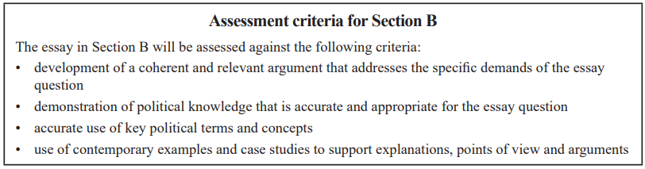

**END OF QUESTION AND ANSWER BOOK**

